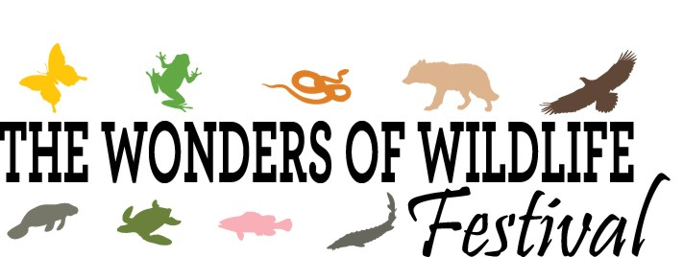Registration Form

I am a: Vendor (selling goods) $75.00* Exhibitor (no sales) $25.00 Sponsor

Business Name:__________________________________________________________________________

Website:___________________________________ Contact Name:_________________________________

Email:_________________________________________________ Phone:____________________________

Mailing Address: __________________________________________________________________________

City: ____________________State: _________Zip:_________________________

IMPORTANT INFORMATION: You can pay by check, PayPal or you can call us with your credit card payment.

Booths are approximately 10' x 10'. Tents, tables and chairs are not provided. You will need to bring your own equipment. This is an outdoor event so there is no power or in-door sites available. Booths are $75.00 if you are selling goods. For Vendors not selling goods or without money exchanging hands booths are $35.00. If you are a non-profit and you are collecting donations only, the fee is $35.00. Anyone cancelling prior to October 10, 2022 will be charged a $10.00 cancellation fee. After October 10th, there will be no refunds for cancellations.
We will assign booths during the week prior to the event and communicate that via email.

*If you were a vendor in our first Wonders of Wildlife Festival, the 2019 rate of $50.00 will apply again for this year's festival.

VENDORS: Basic description of items to be sold:__________________________________________________

EXHIBITORS: Basic Description of what you will have/offer at your booth: __________________________________________________________________________________________

__________________________________________________________________________________________

We are a family centered event so we encourage you to have an activity people can participate in. If you need ideas, contact Nancy Murrah. We will be setting up a Migration Station Activity where people go through 24 "Stops" along a migratory path. If you would like to participate in this activity, it just involves you putting up one of the stops along the way (a 8 1/2 x 11 sign) at your booth. If you would like to participate in this activity check here: Yes No
__________________________________________________________________________________________
PAYMENT INFORMATION:
Mail completed registration to : Raptor Center of Tampa Bay, P.O. Box 3638, Brandon, FL 33509
Email registration or questions to: Nancy@RaptorCenterofTampa.org Phone 813-205-1851
Check enclosed: Yes No

